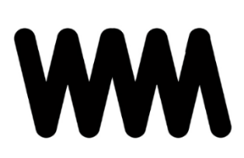

WAM BLOCK PARTY APPLICATION

Event: Westchester Arts & Music Block Party
Date: Saturday, September 21, 2019
Time: 12pm to 8pm
Location: Emerson Avenue between 80th St. and 80th Pl., Westchester, CA 90045

VENDOR INFORMATION

Vendor Type* (choose only one): Art/Craft __ | Commercial Business __ | Non-Profit __ | Other __
Vendor Description* (Please give a complete description of your art, product or service):
___________________________________________________________________________________
___________________________________________________________________________________
___________________________________________________________________________________
___________________________________________________________________________________

Vendor Business Name*: _______________________________________________
Contact Name*: _____________________________________________________
Contact Email*: _____________________________________________________
Contact Phone*: _____________________________________________________
Vendor Website: _____________________________________________________
*required

Booth Space(s) Requested: ______ x $118 ea. (space size: 10’ X 12’) = __________ Total due
via PayPal/Credit Card upon acceptance.

Email completed application along with a minimum of 3 samples (Art/Craft Vendors only) to jkhdesign@earthlink.net Please insure file sizes do not exceed 2 MB per image.

Applications will be reviewed and upon acceptance, vendors will be notified by email and supplied
with a link for their PayPal/Credit card payment. Accepted vendors will have 10 business days from the date of acceptance to pay for and secure their booth spaces.

APPLICATION DEADLINE: 5pm Friday, August 23, 2019. NO APPLICATIONS WILL BE ACCEPTED AFTER THIS DATE.

QUESTIONS?

Julie Henriksen
T: 310.508.6612
E: jkhdesign@earthlink.net
